**Installing Nagios server in centos 7**

**NAGIOS** is a monitoring tool

* Monitors all the activities of the hosts and services that are configured on it.
* It monitors the working condition and status of all the hosts and services that are configured on the Nagios server.
* The state of the host is depicted in three types of statuses to the administrator. The 3 statuses are **OK, WARNING AND CRITICAL**.
* In order to run NAGIOS we need to install certain dependencies. They are HTTPD, XINETD, NRPE and PHP
* Every time we start the monitoring system we need to start the HTTPD, XINETD and the NRPE services to run NAGIOS.

Following are the steps that can be followed to install, configure and run NAGIOS:

Installation of PHP ( Dependency for NAGIOS ):

Command used: yum install php*

The yum package installer installs all the packages needed along with the related dependencies.

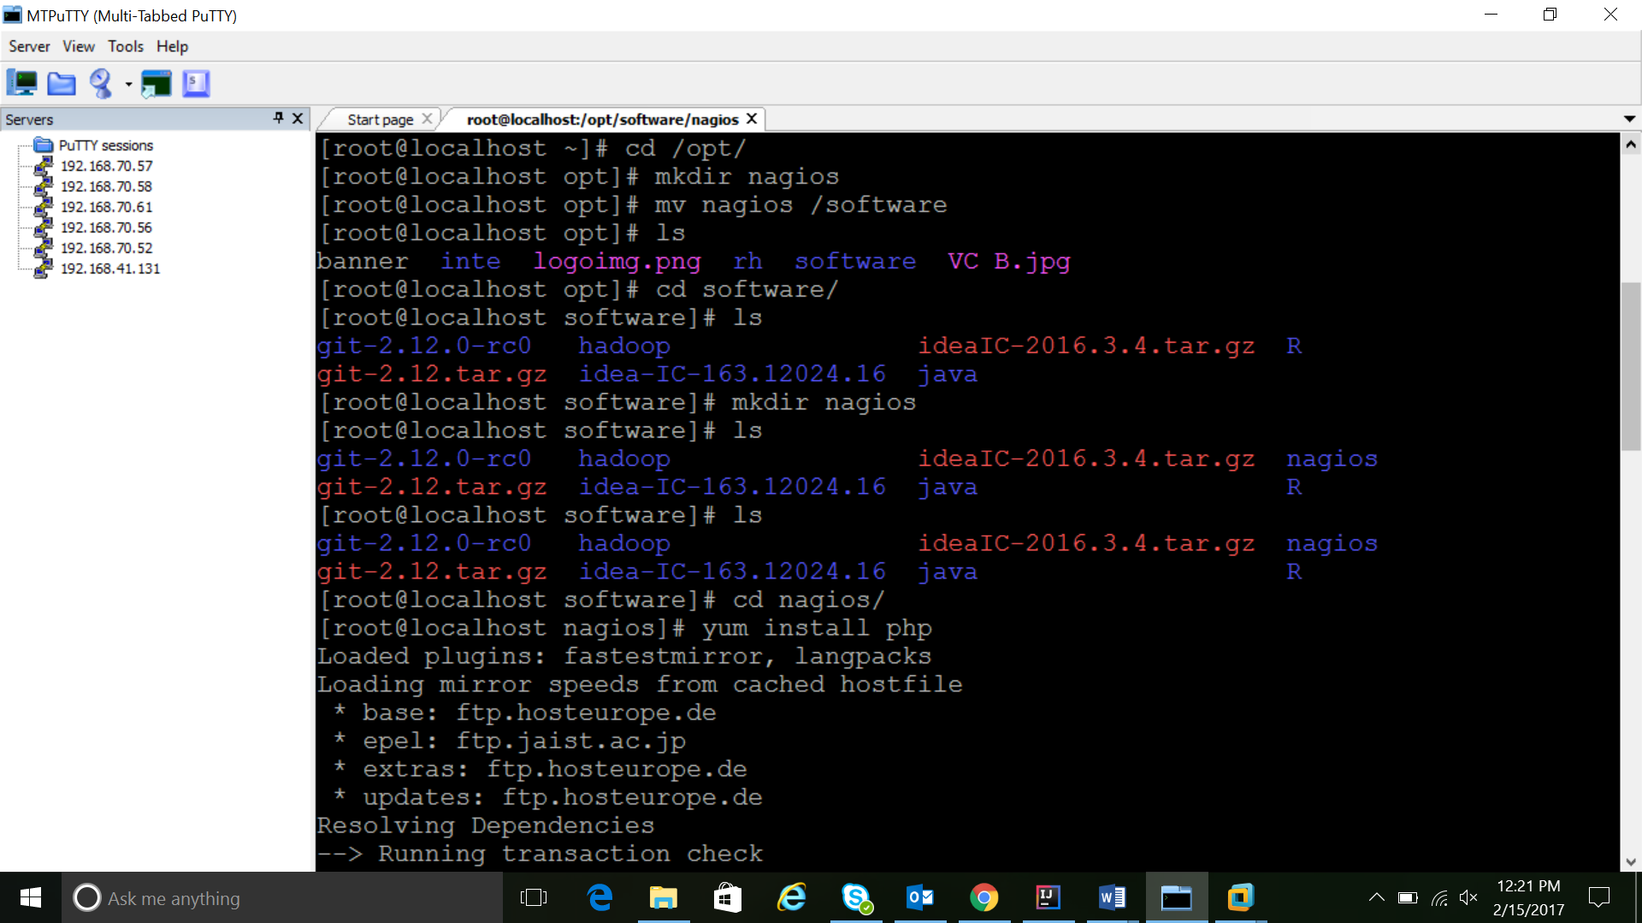

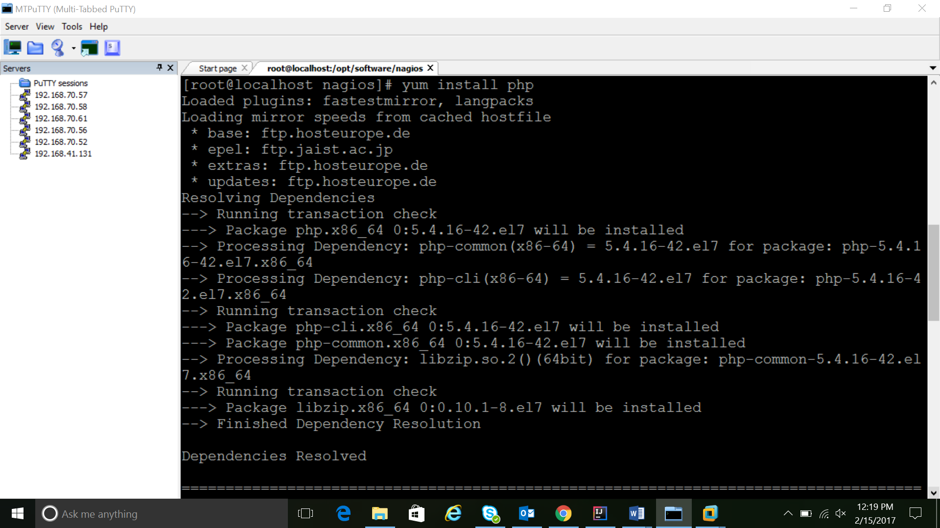

Installation of HTTPD service:

Command used: yum install httpd*

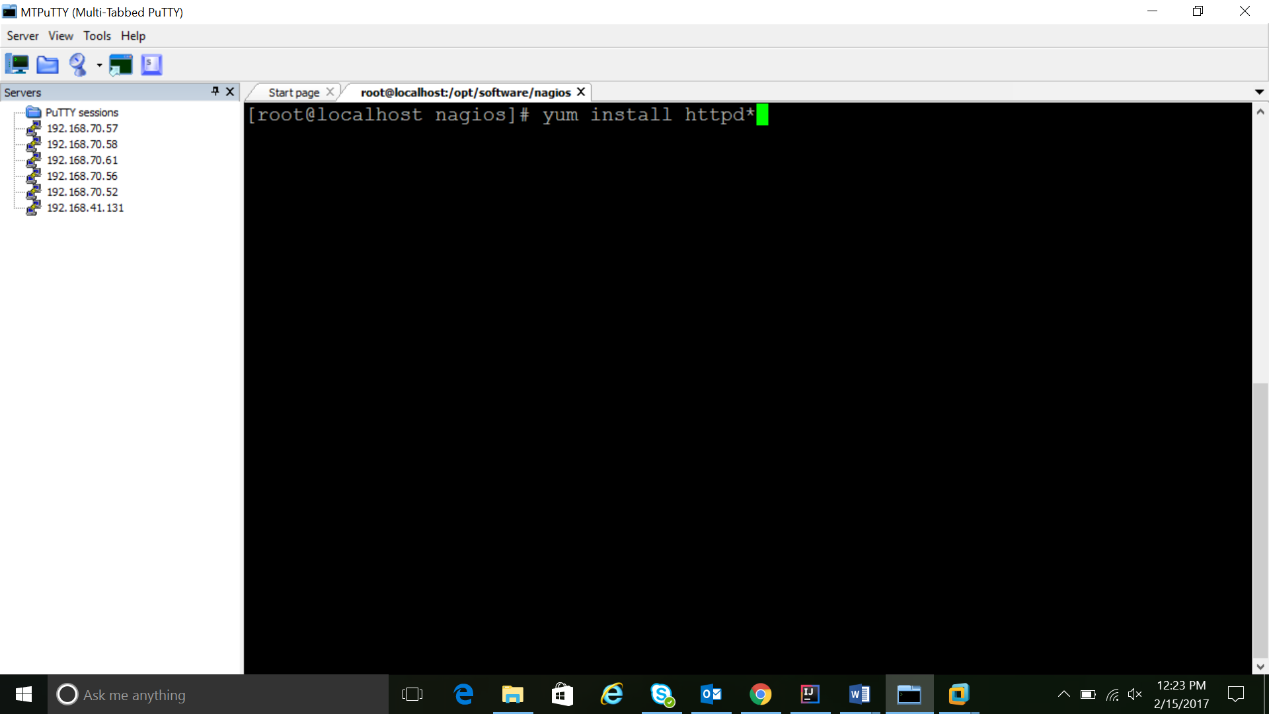

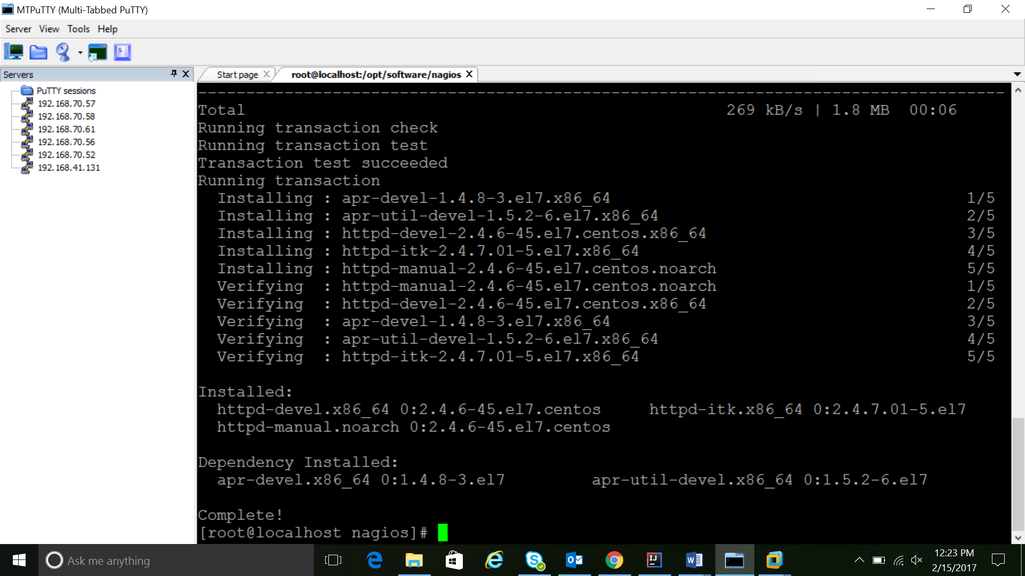

This section will cover how to install Nagios 4 on your monitoring server. You only need to complete this section once.

Install Build Dependencies

--------------------------

yum install gcc glibc glibc-common gd gd-devel make net-snmp openssl-devel xinetd unzip

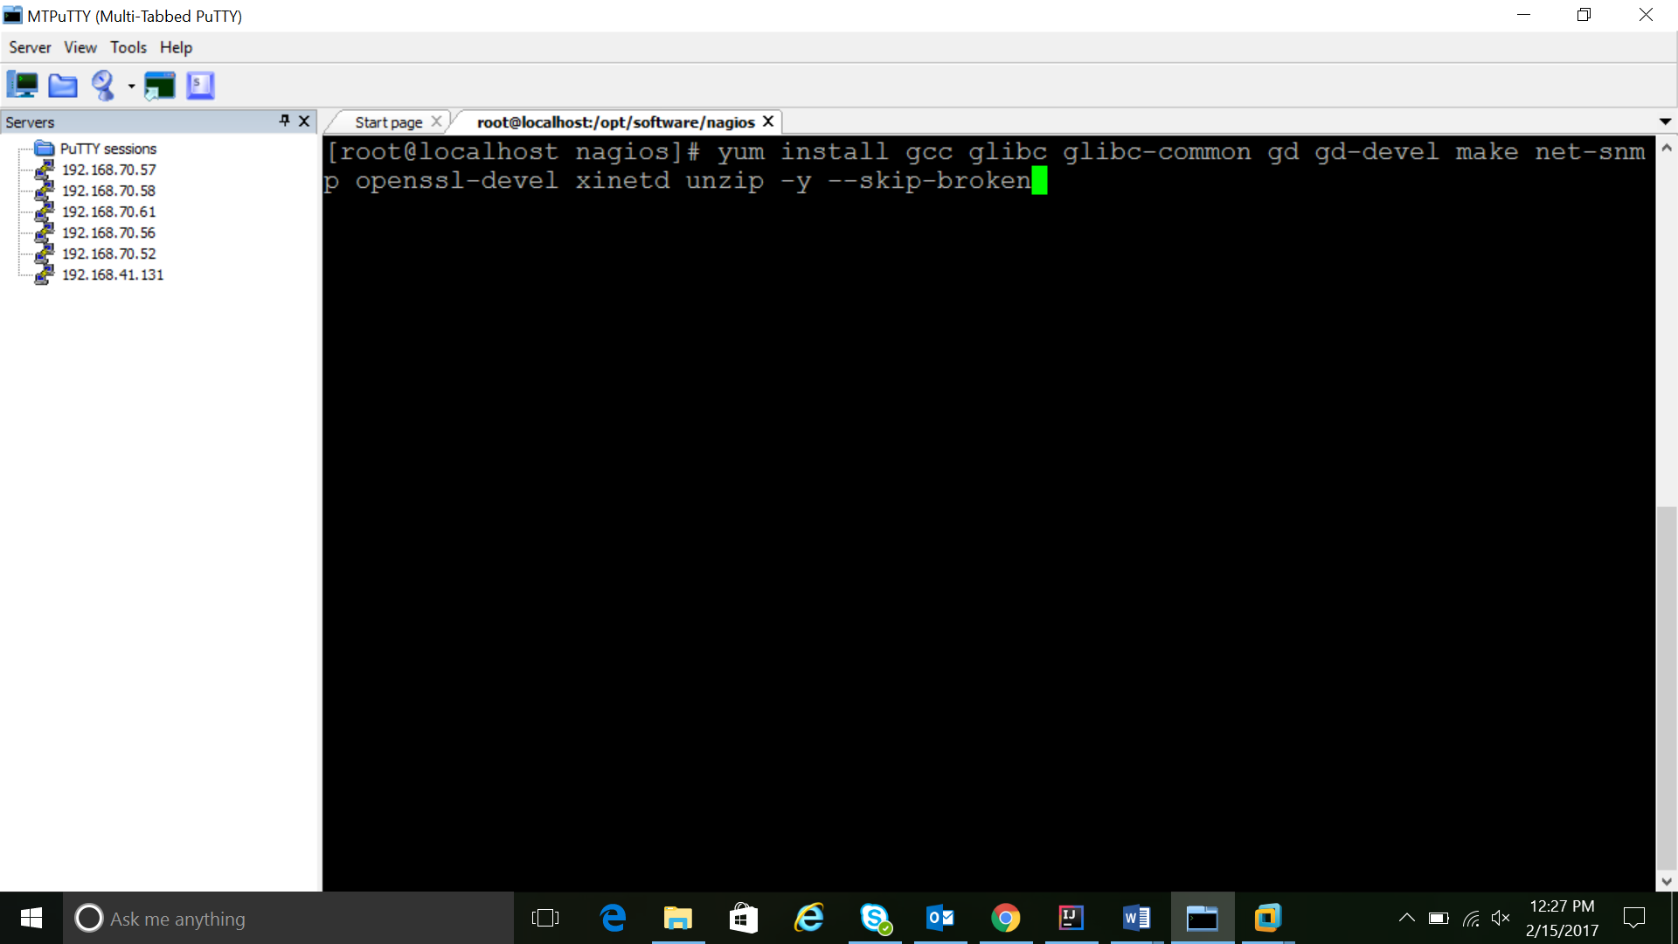

In order to use Nagios we need to work from a specific user who will be solely responsible for the monitoring purpose of the systems. So we need to create users for monitoring and a group for the monitoring users

**ONLY THE USERS BELONGING TO THE NAGIOS GROUP CAN MONITOR THE SYSTEMS**

Create Nagios User and Group

----------------------------

* useradd Nagios

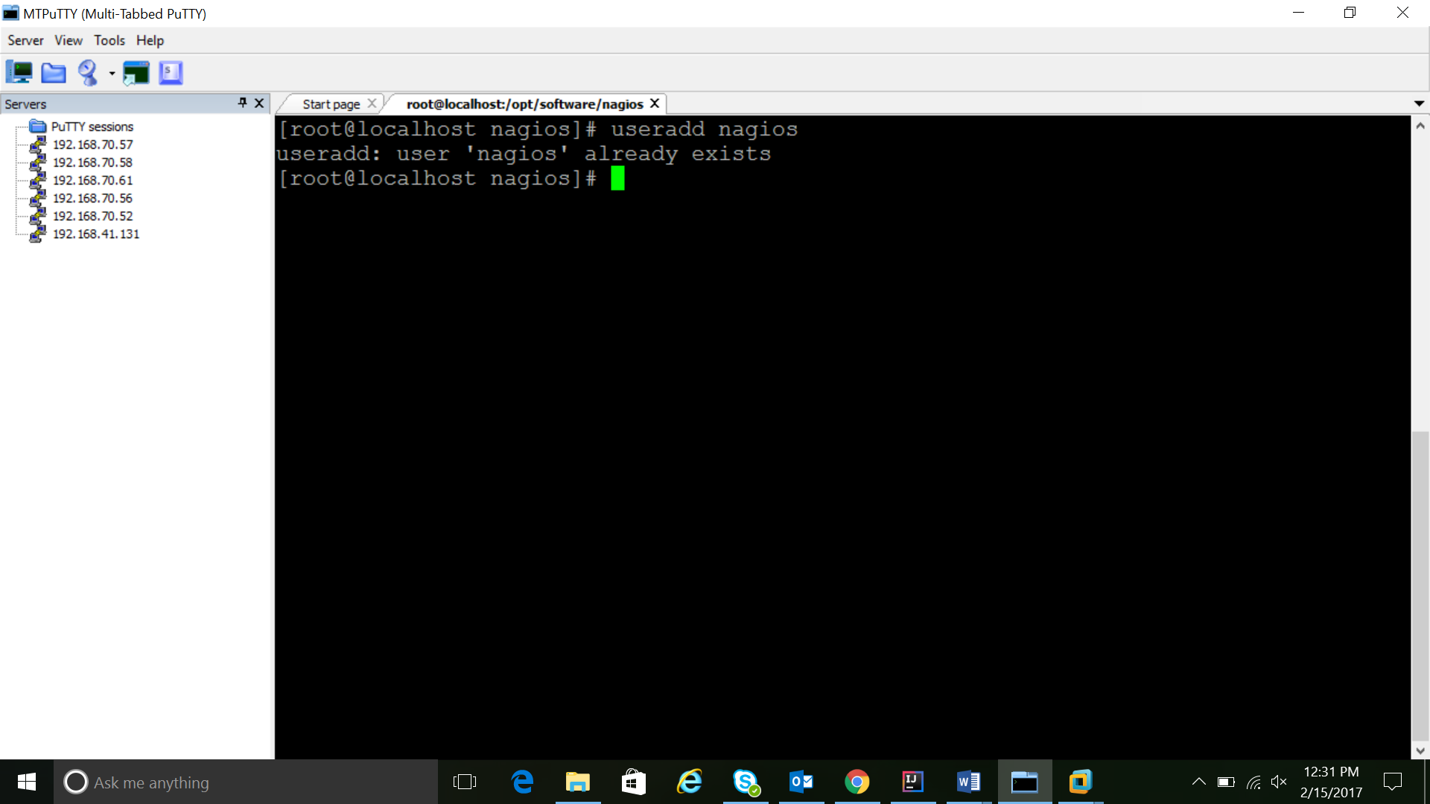

* groupadd nagcmd
* usermod -a -G nagcmd nagios

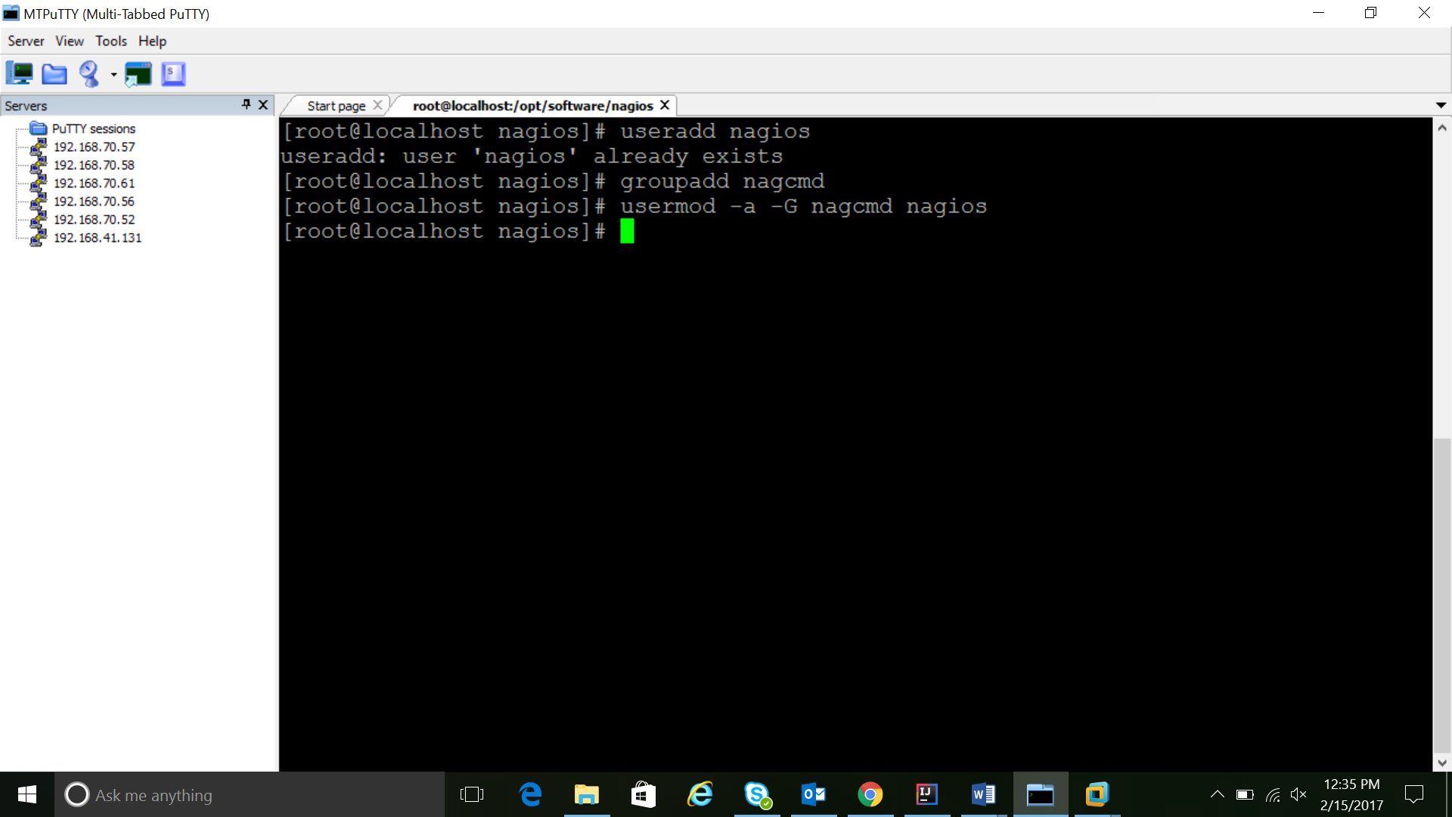

**Install Nagios Core**

Command used: wget <https://assets.nagios.com/downloads/nagioscore/releases/nagios-4.1.1.tar.gz>

**Extract the Nagios archive with this command:**

Command used: tar -xvzf nagios-4.1.1.tar.gz

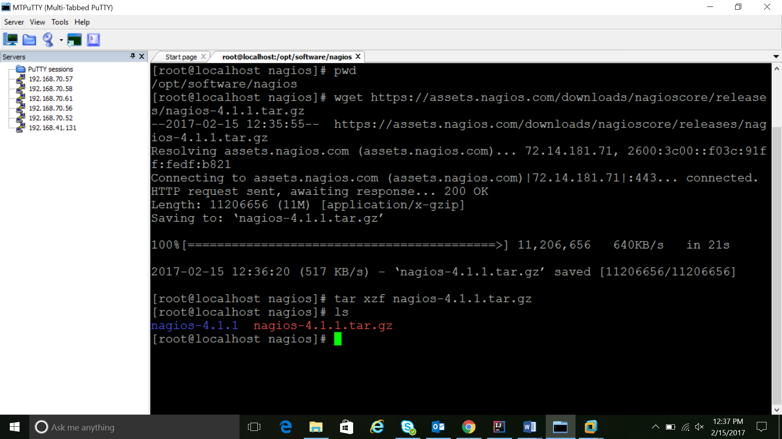

**Before building Nagios, we must configure it with this command:**

--------------------------------------------------------

Command used: ./configure --with-command-group=nagcmd

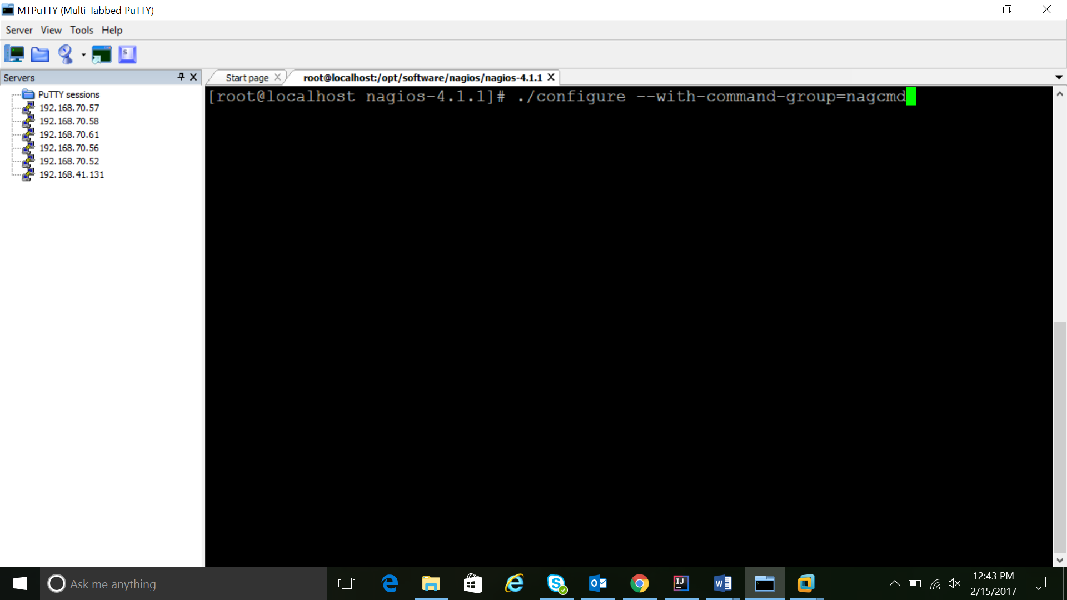

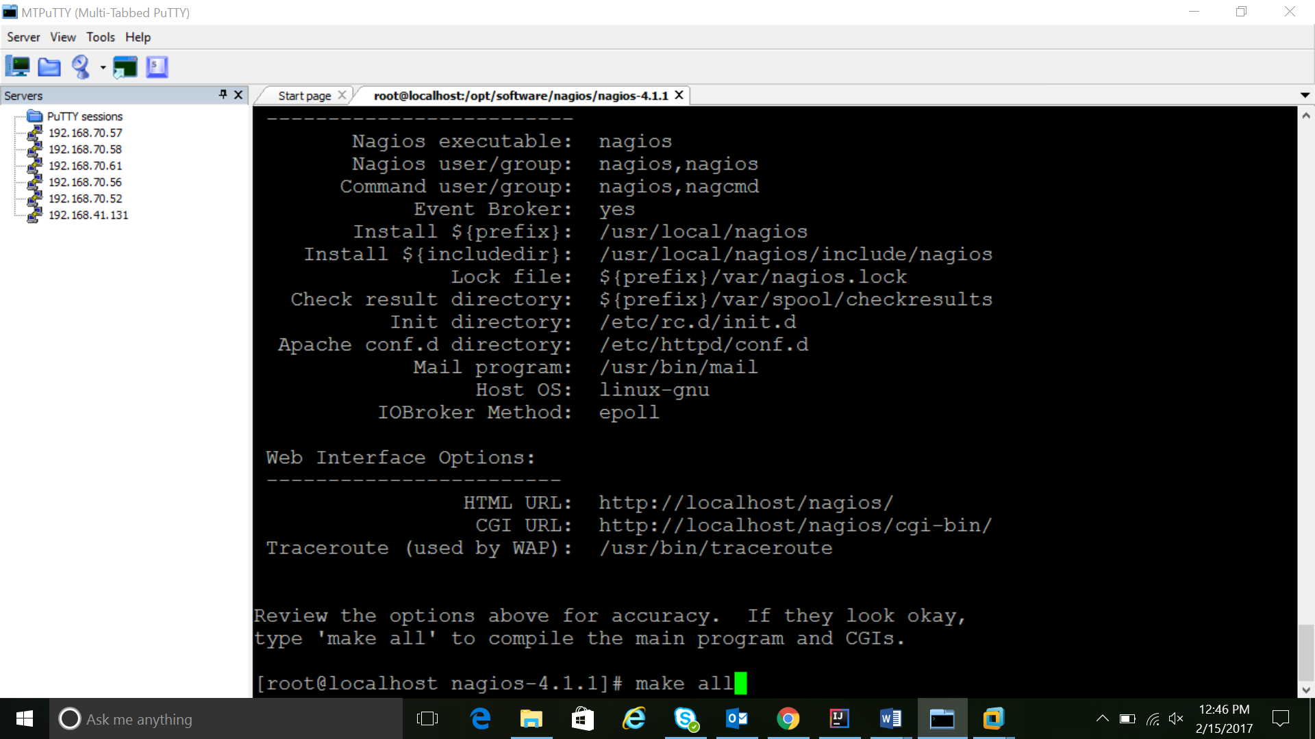

**Now compile Nagios with this command:**

This command complies all the binaries that are part of the NAGIOS package along with its dependencies

* Command used: make all

This portion contains of all the configuration commands that are required to run the NAGIOS monitoring service successfully. These commands are included for installing the dependencies too for running the monitoring service.

**Now we can run these make commands to install Nagios, init scripts, and sample configuration files:**

--------------------------------------------------------------------------------------------

* make install
* make install-commandmode
* make install-init
* make install-config
* make install-webconf

**In order to issue external commands via the web interface to Nagios, we must add the web server user, apache, to the nagcmd group:**

* usermod -G nagcmd apache

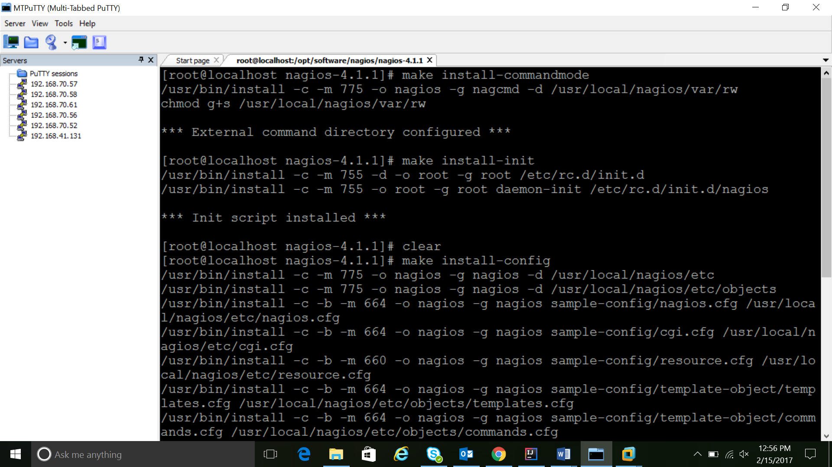

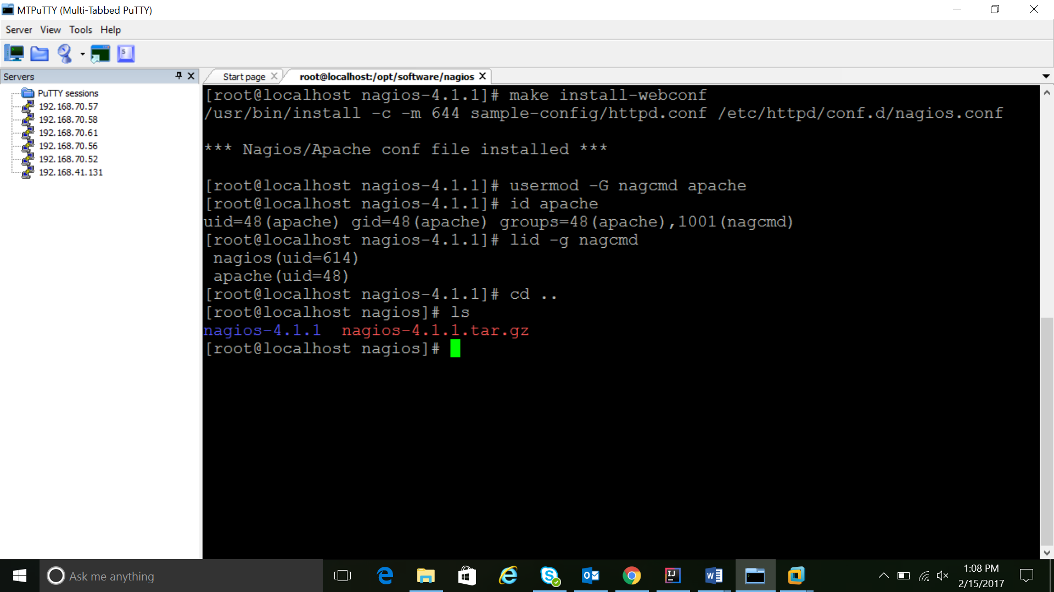

**Install Nagios Plugins**

Now we have to install the Nagios plugins.

latest version is Nagios Plugins 2.1.1. Download it to your home directory

* Command used: # wget http://nagios-plugins.org/download/nagios-plugins-2.2.0.tar.gz

Extract Nagios Plugins archive with this command:

* tar -zxf nagios-plugins-2.2.0tar.gz
* cd nagios-plugins-2.2.0/

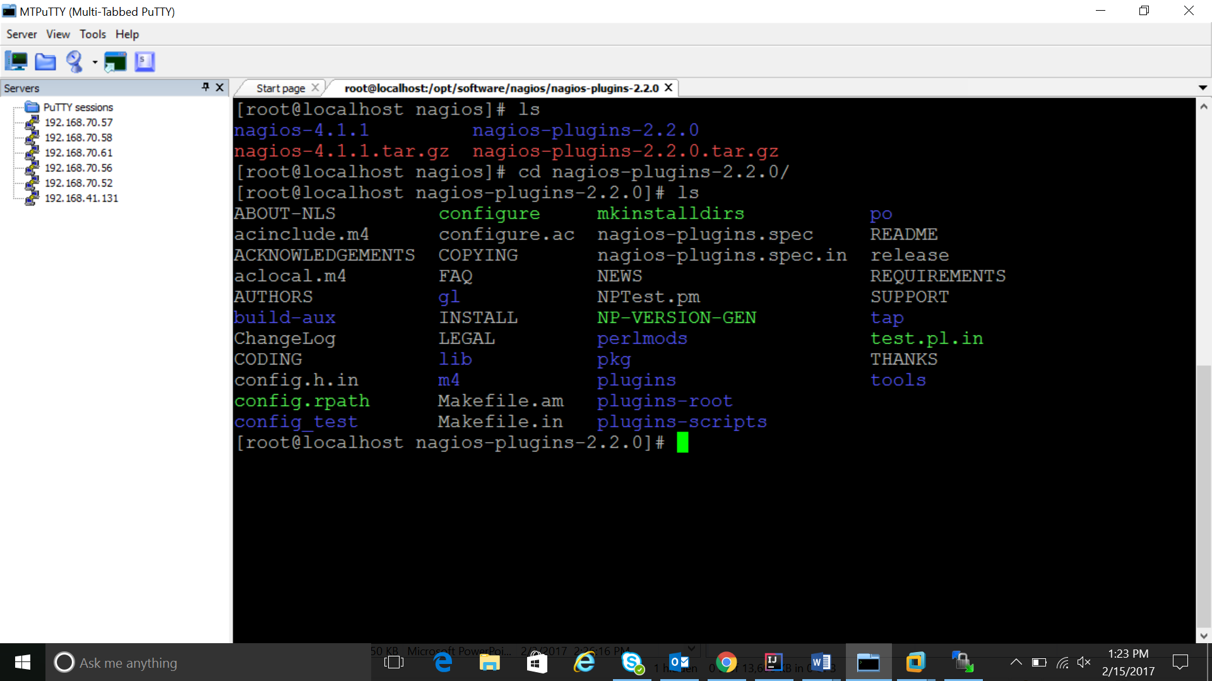

Before building Nagios Plugins, we must configure it. Use this command:

* ./configure --with-nagios-user=nagios --with-nagios-group=nagcmd --with-openssl

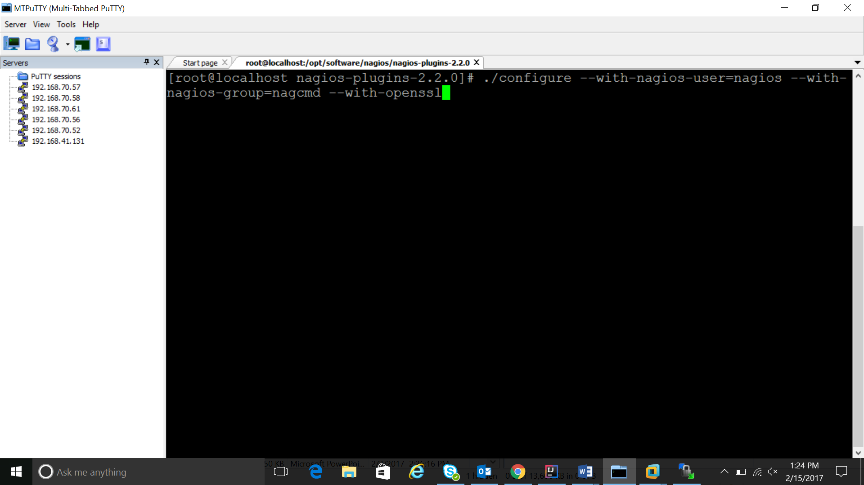

Now compile Nagios Plugins with this command:

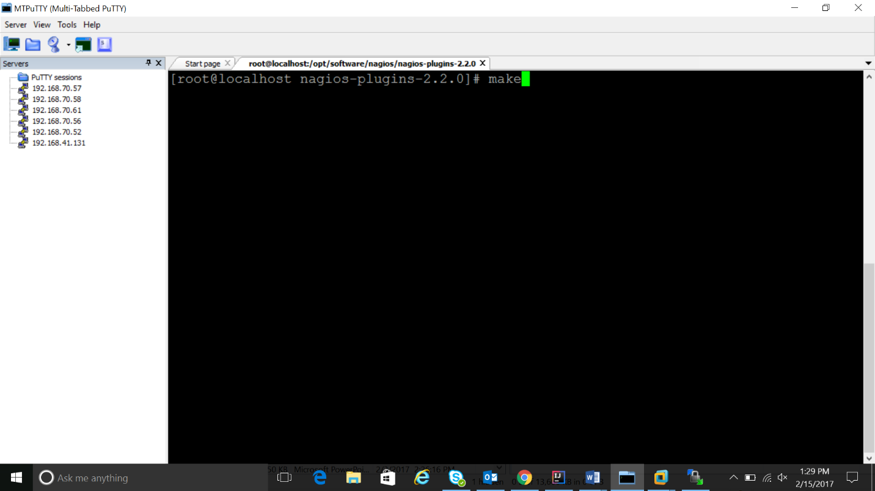Command used: make2

Then install it with this command:

Command used: make install

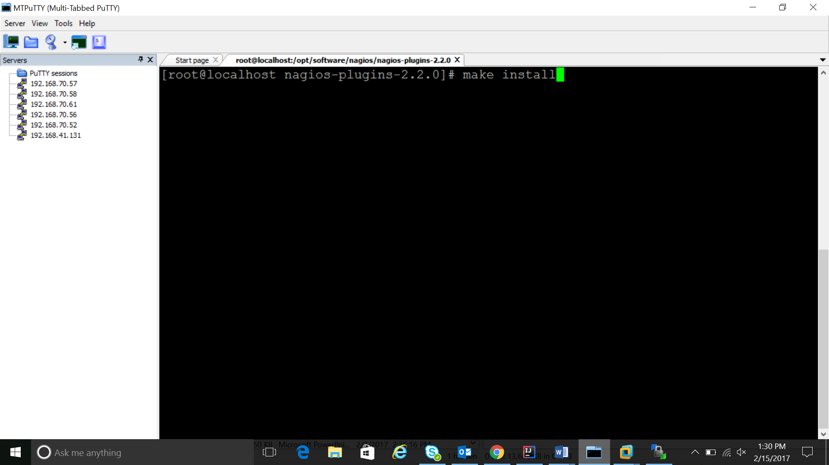

Install NRPE

=============

**Now we have to configure the client node. NRPE service needs to be configured only in the Client side.**

latest release is 2.15. Download it to your home directory

* wget <http://downloads.sourceforge.net/project/nagios/nrpe-2.x/nrpe-2.15/nrpe-2.15.tar.gz>
* tar -zxf nrpe-2.15.tar.gz
* cd nrpe-2.15.

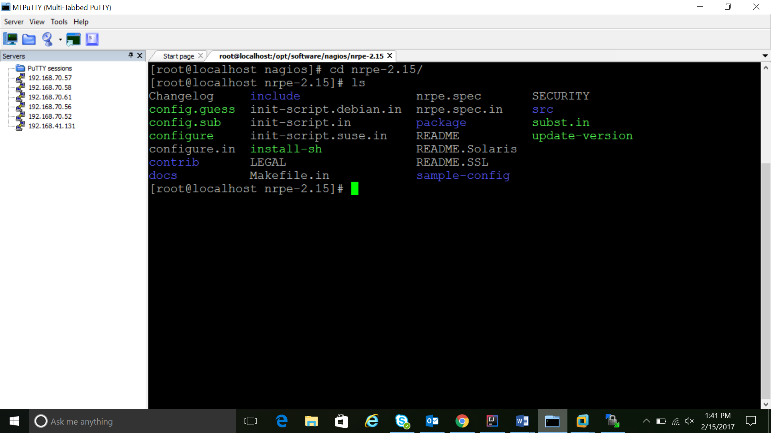

**Configure NRPE with these commands:**

* ./configure --enable-command-args --with-nagios-user=nagios --with-nagios-group=nagcmd --with-ssl=/usr/bin/openssl --with-ssl-lib=/usr/lib/x86_64-linux-gnu

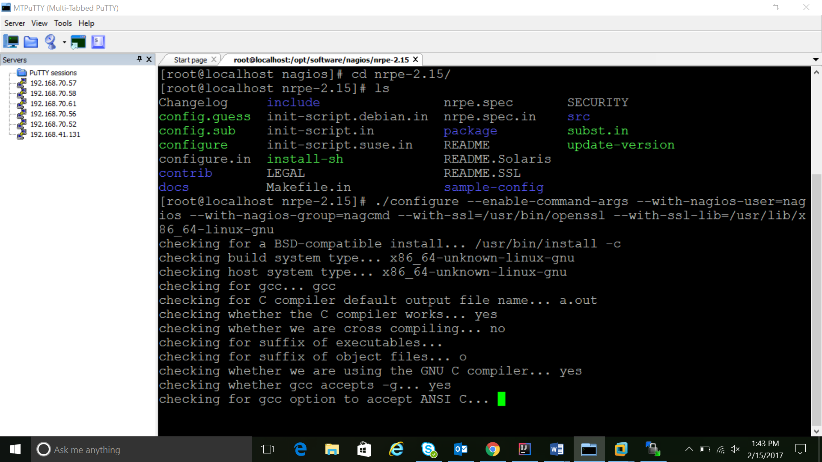

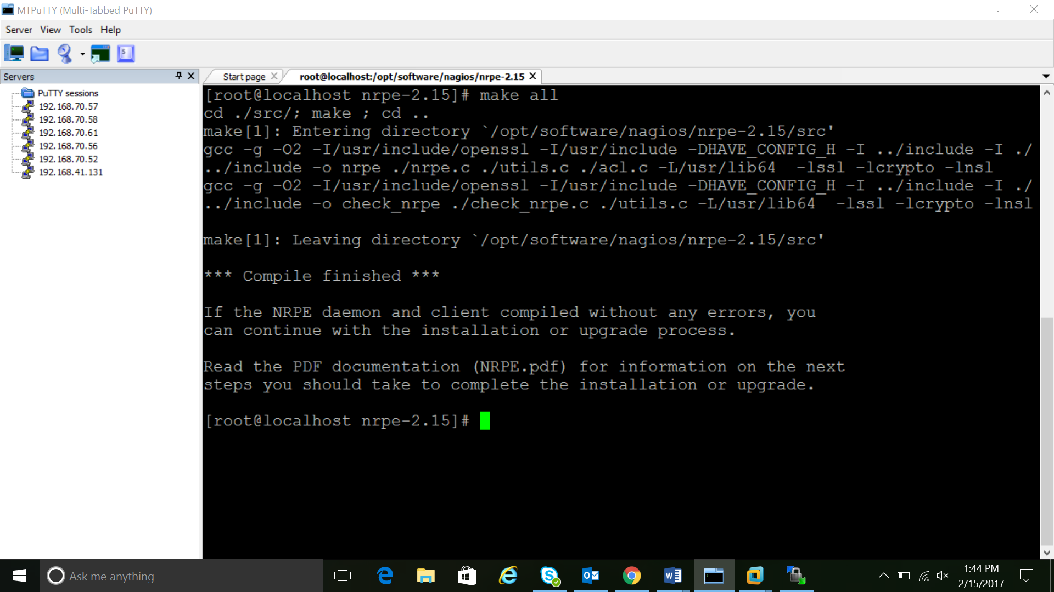

Now build and install NRPE and its xinetd startup script with these commands:

-------------------------------------------------------------------------------

* make all
* make install
* make install-xinetd
* make install-daemon-config

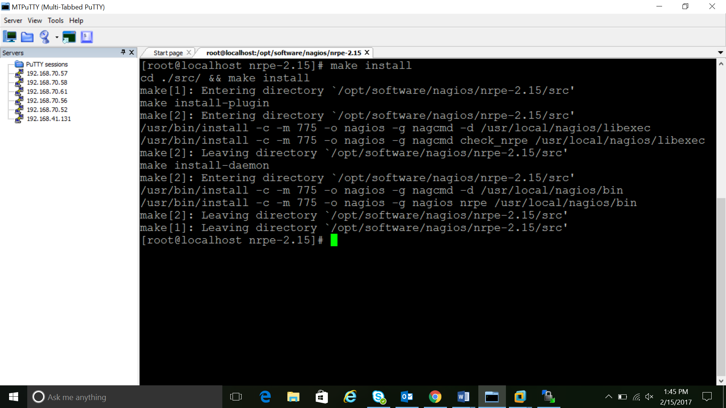

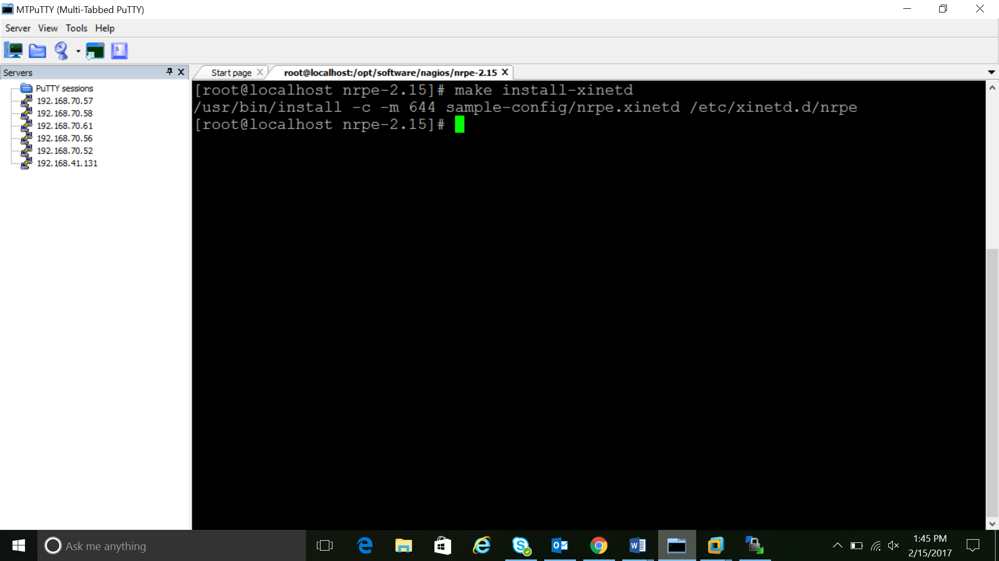

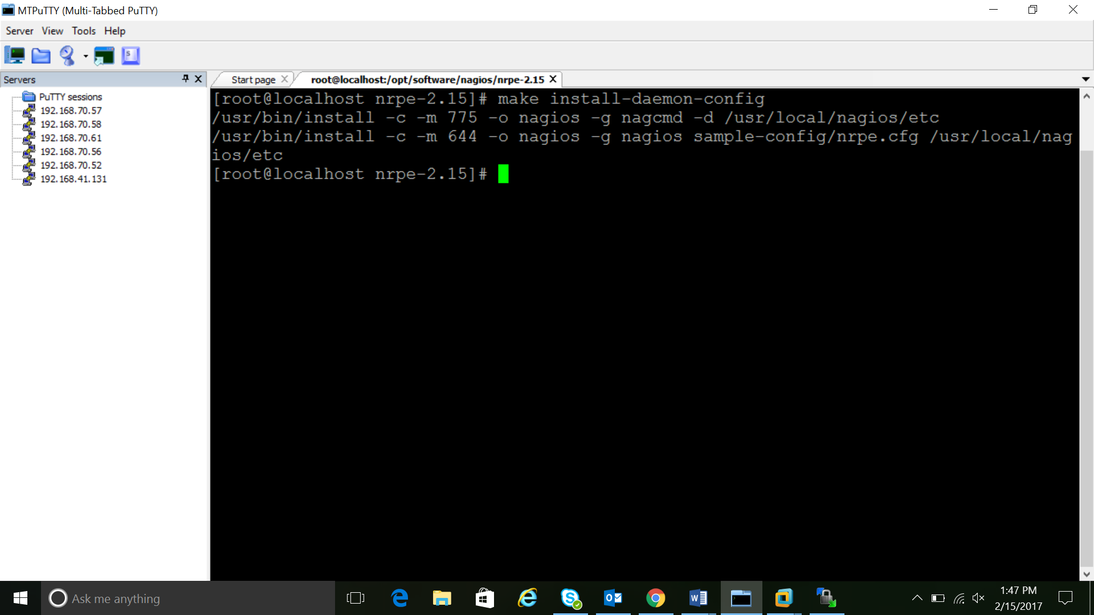

Open the xinetd startup script in an editor:

* vi /etc/xinetd.d/nrpe

Modify the only_from line by adding the private IP address of the your Nagios server to the end (substitute in the actual IP address of your server)

* Only from = 127.0.0.1 16.184.47.43

Save and exit. Only the Nagios server will be allowed to communicate with NRPE.

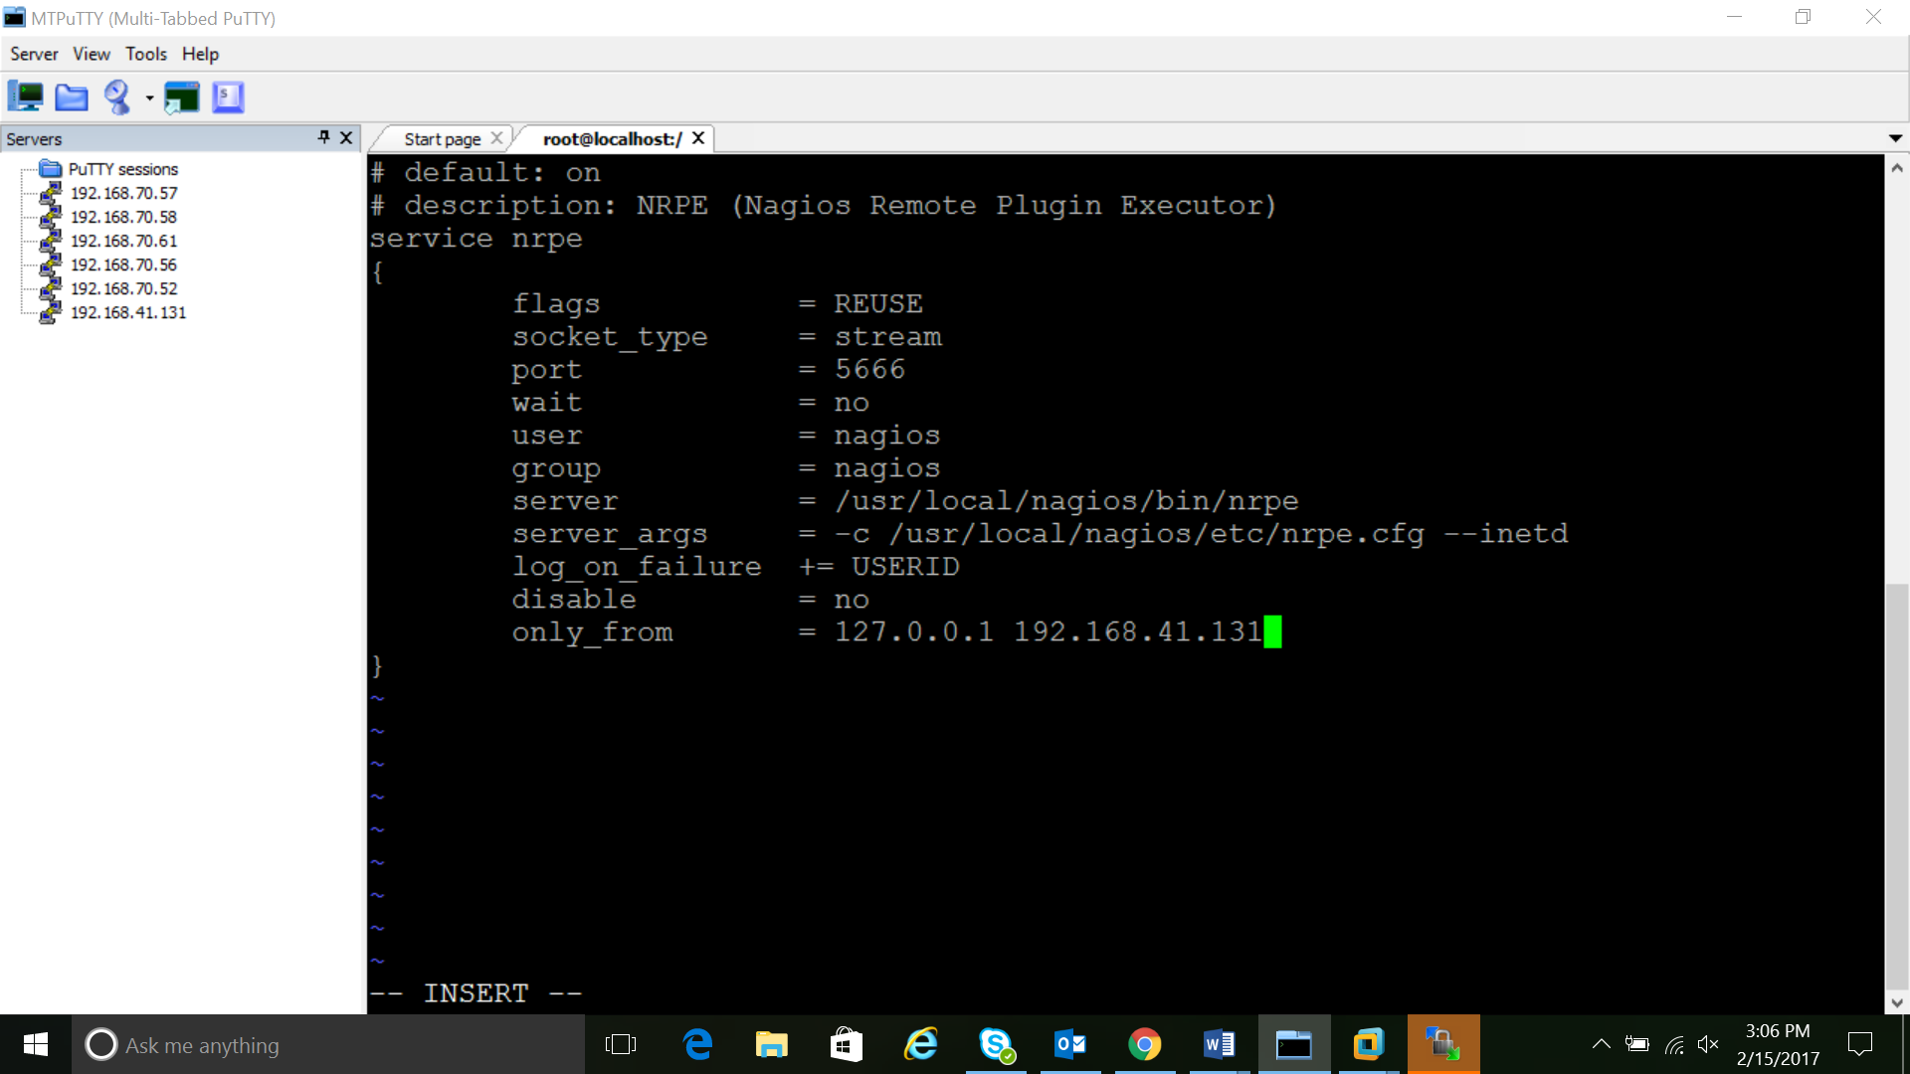

Restart the xinetd service to start NRPE:

* service xinetd restart

Now that Nagios 4 is installed, we need to configure it.

=========================================================

Configure Nagios

=================

Open the main Nagios configuration file

vi /usr/local/nagios/etc/nagios.cfg

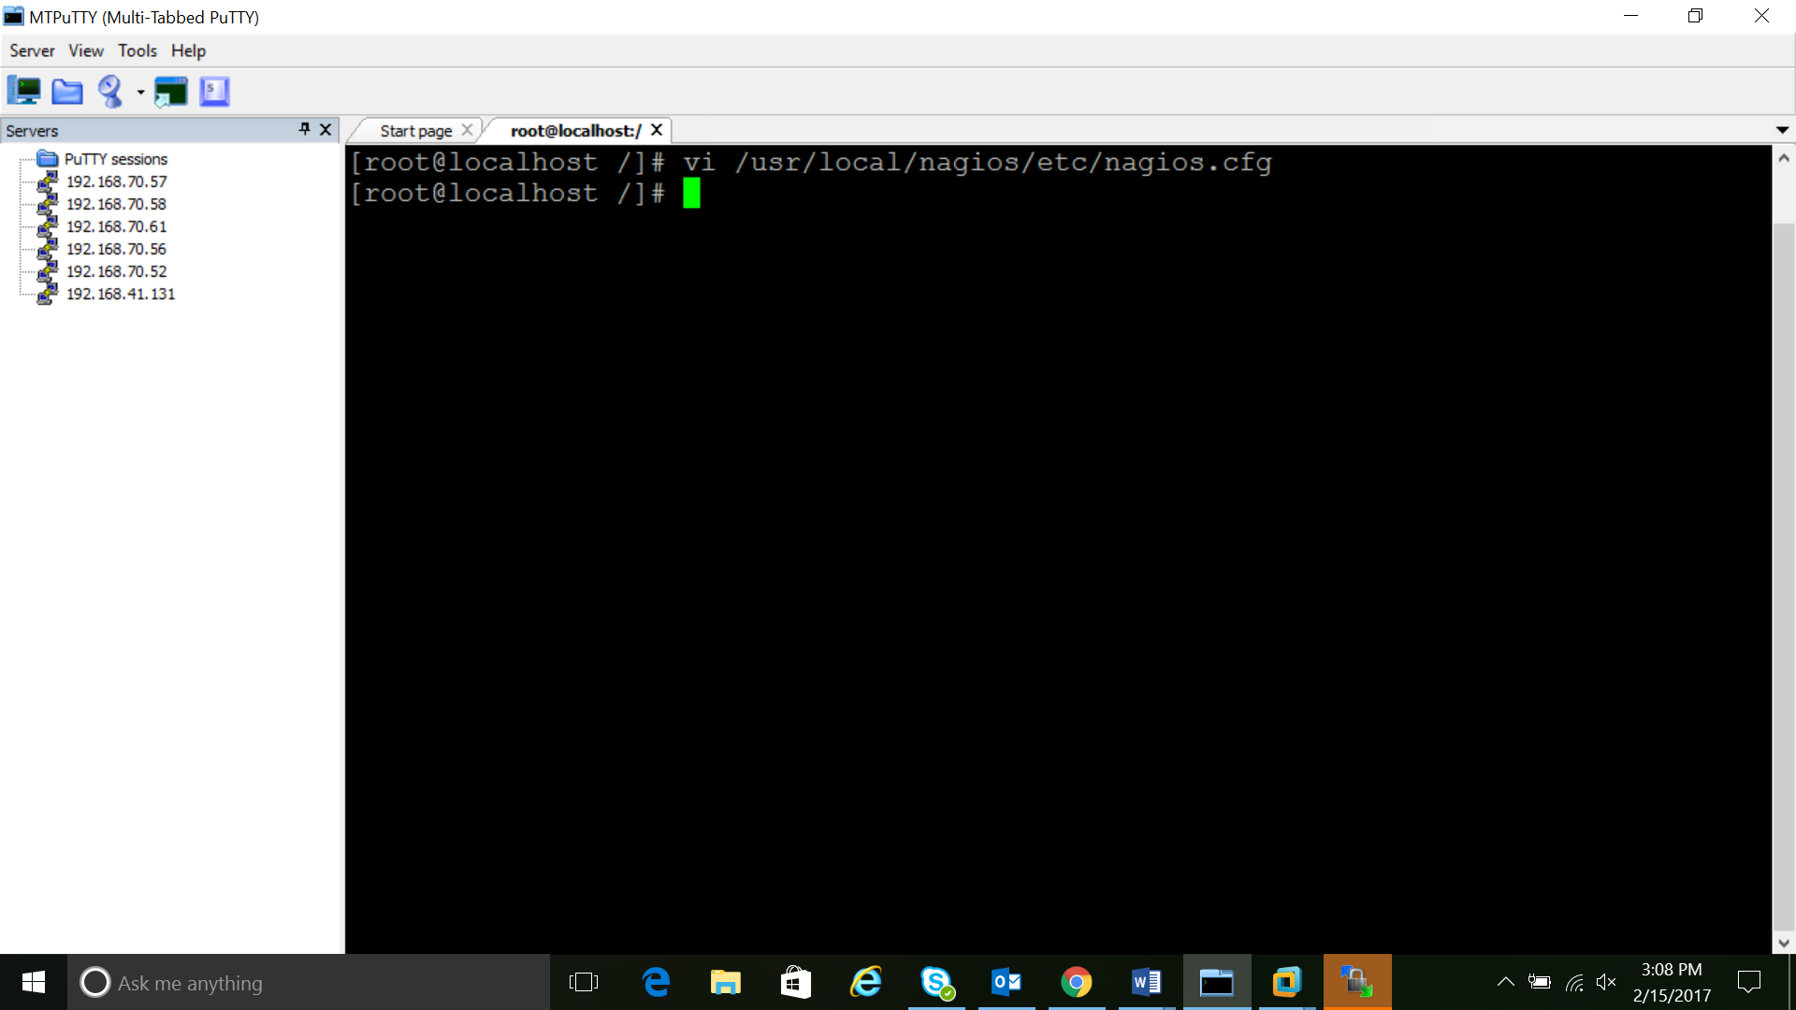

Now find an uncomment this line by deleting the #:

cfg_dir=/usr/local/nagios/etc/servers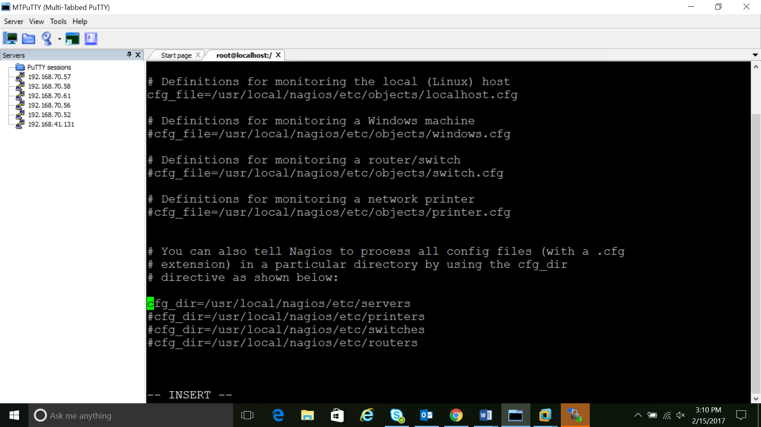

Save and exit.

Now create the directory that will store the configuration file for each server that you will monitor

* mkdir /usr/local/nagios/etc/servers

save it as filename.cfg inside the above mentioned path.

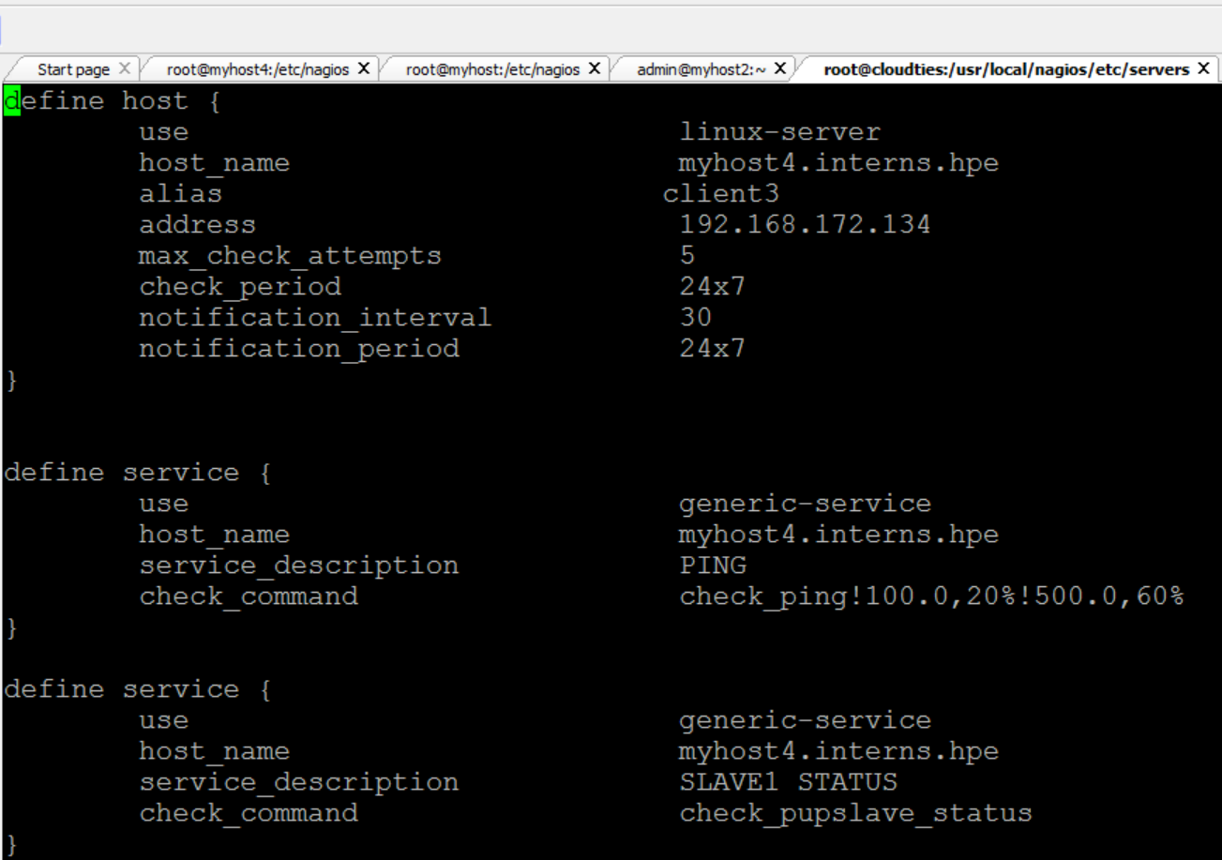

Configure Nagios Contacts

-------------------------

Open the Nagios commands configuration

* vi /usr/local/nagios/etc/objects/commands.cfg

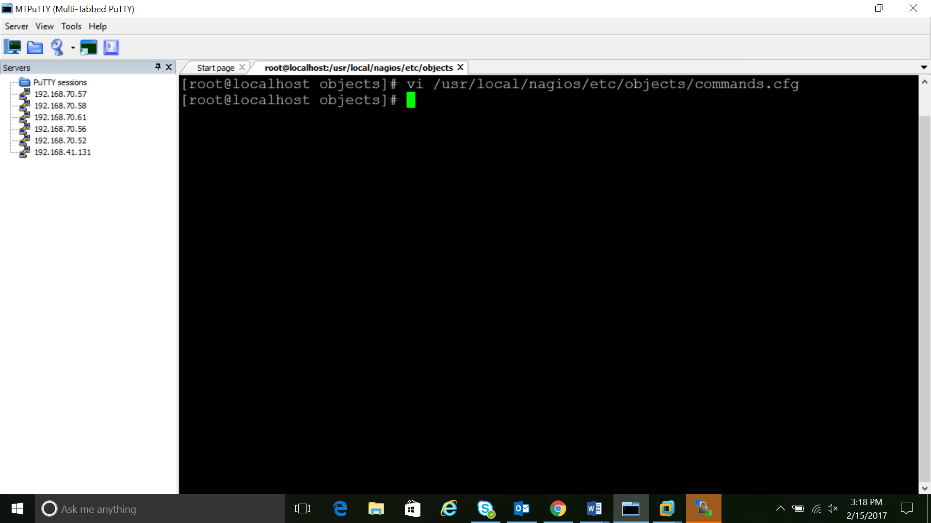

Configure check_nrpe Command

----------------------------

Let's add a new command to our Nagios configuration:

Add the following to the end of the file:

define command{

command_name check_nrpe

command_line $USER1$/check_nrpe -H $HOSTADDRESS$ -c $ARG1$

}

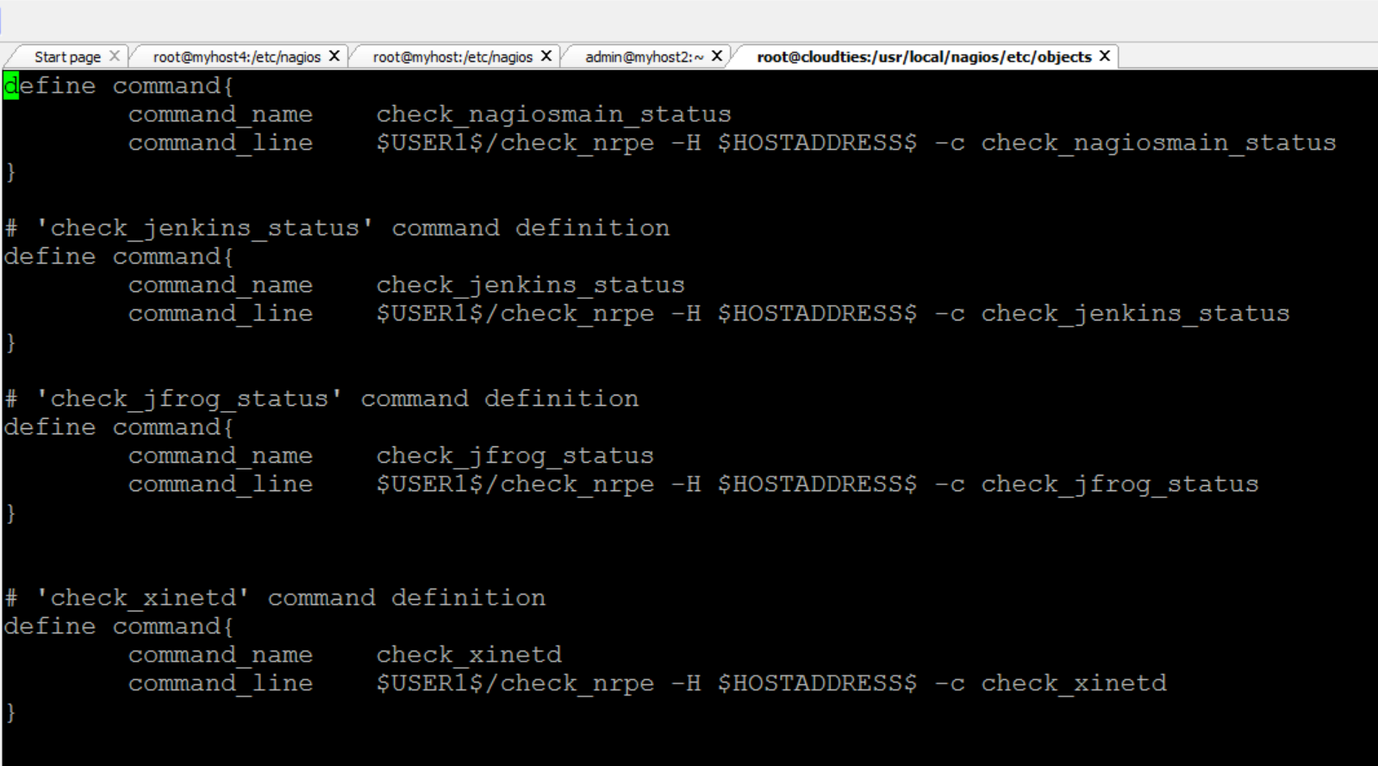

Save and exit. This allows you to use the check_nrpe command in your Nagios service definitions.

Configure Apache

----------------

Create new user **Nagiosadmin** using the command: #useradd Nagiosadmin

* htpasswd -c /usr/local/nagios/etc/htpasswd.users nagiosadmin

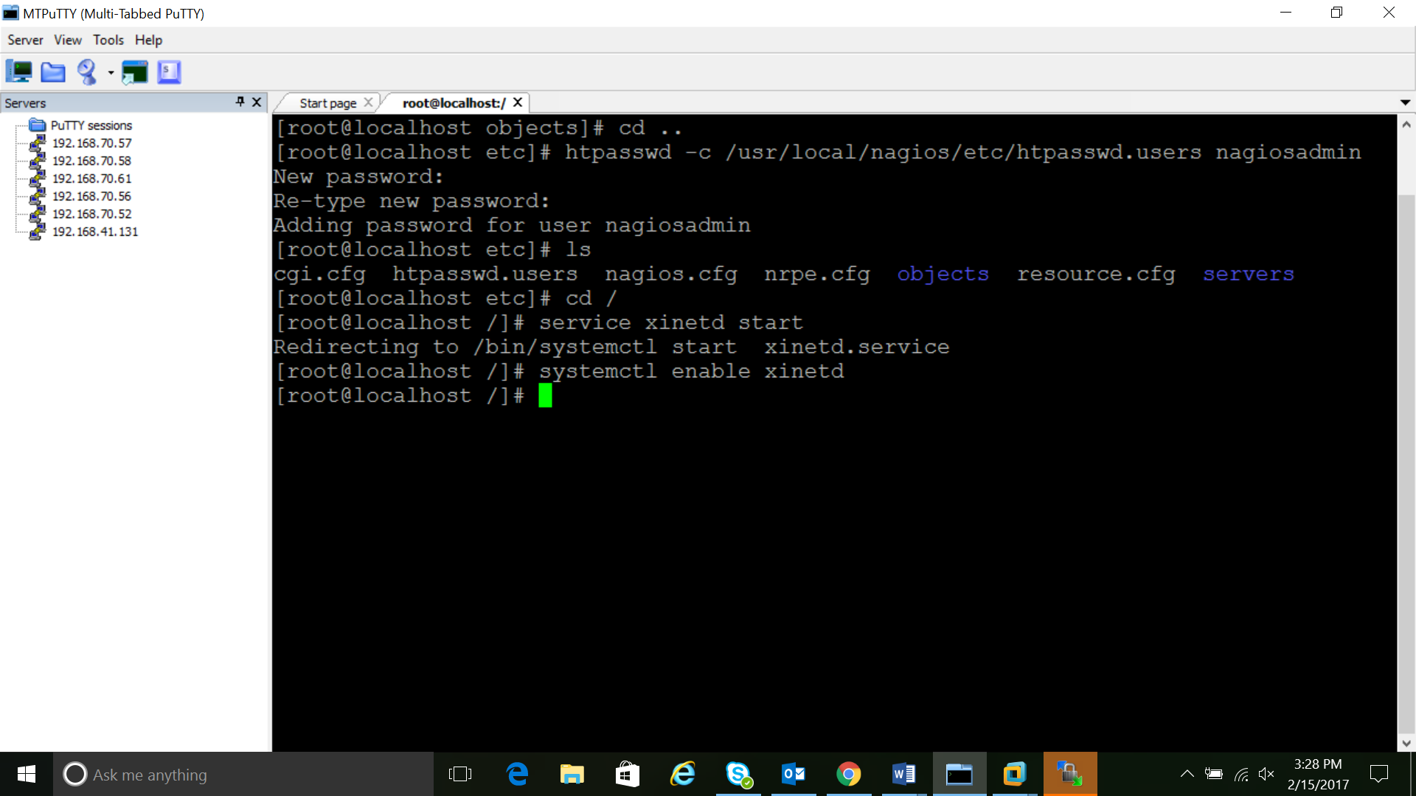

Enter a password at the prompt. Remember this login, as you will need it to access the Nagios web interface.

Nagios is ready to be started. Let's do that, and restart Apache:

------------------------------------------------------------------

**Use following commands to restart the services :**

* service nagios start
* service httpd restart

To enable Nagios to start on server boot, run this command:

* chkconfig nagios on

Accessing the Nagios Web Interface

===================================

Open your web browser, and go to your Nagios server

<http://192.168.41.131/nagios>

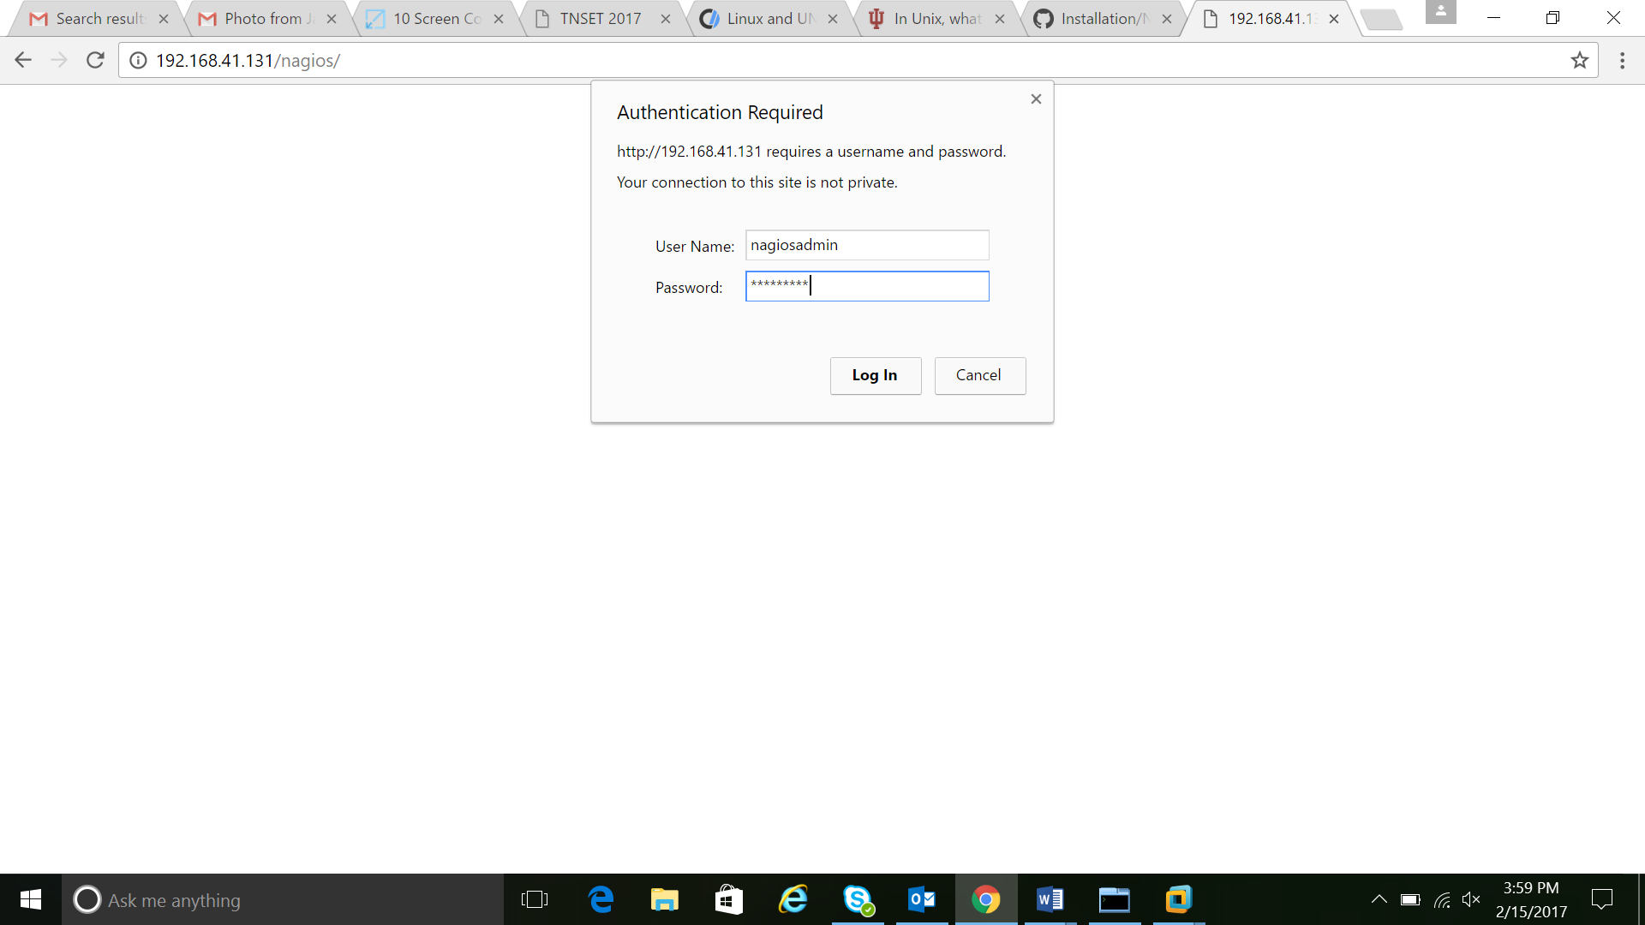

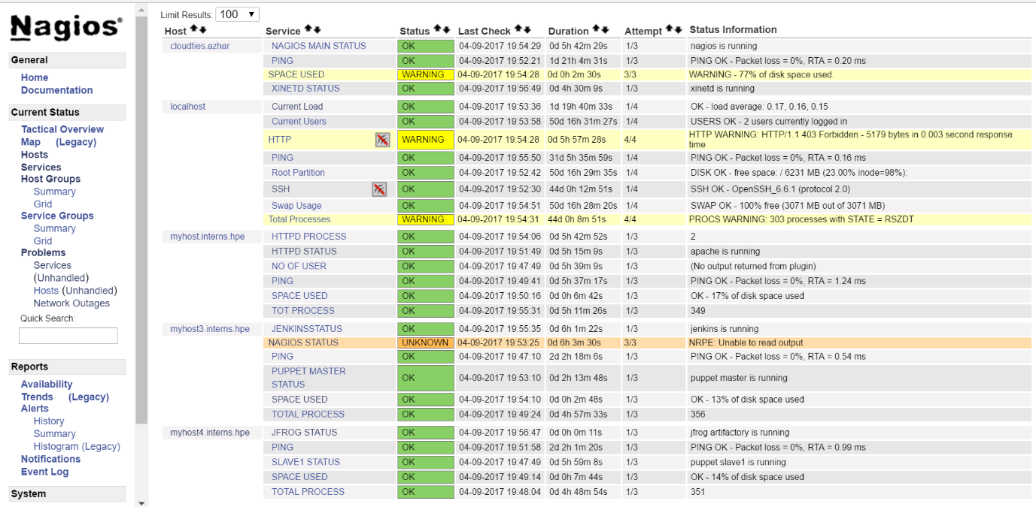

IN CLIENT

===========

Monitoring a Host with NRPE

==============================

Add a new host to Nagios, so it will be monitored

On a server that you want to monitor, install the EPEL repository:

* yum install epel-release

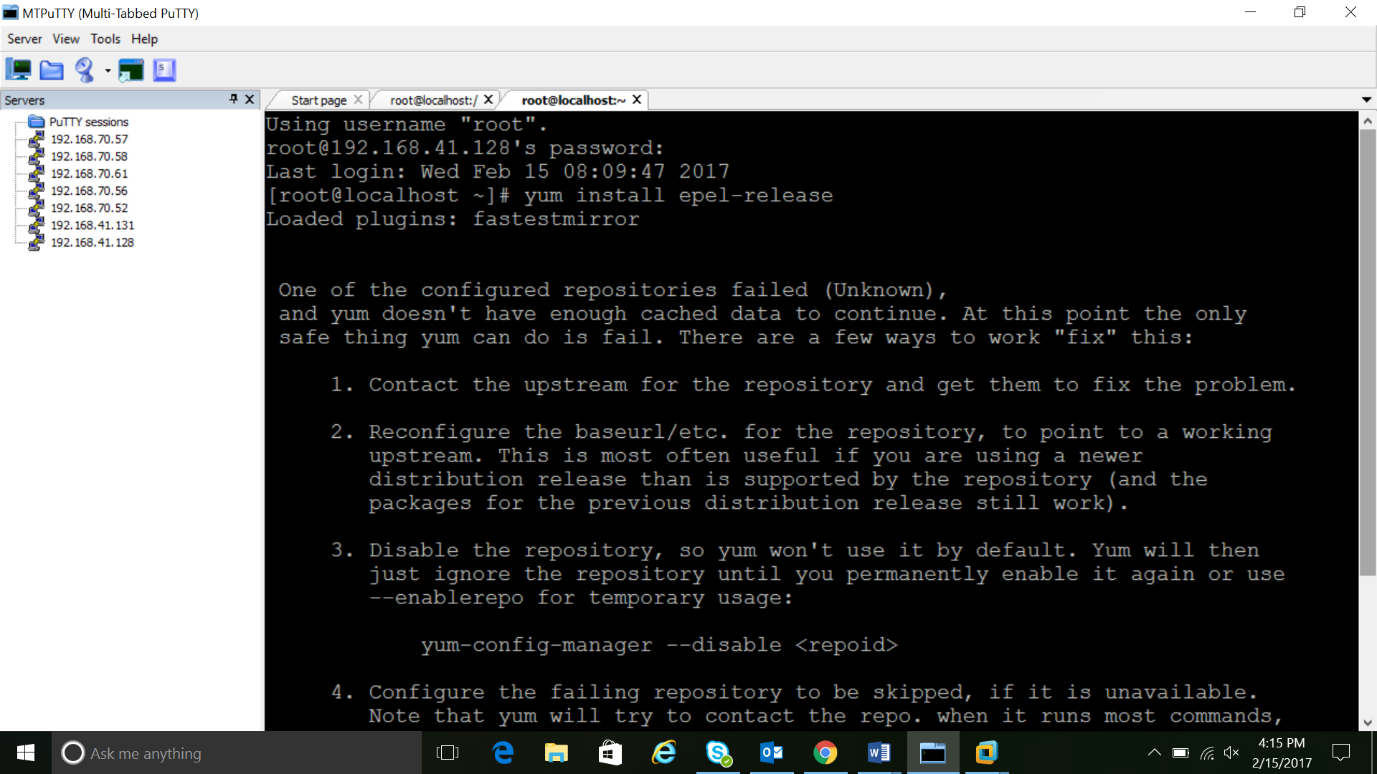

Now install Nagios Plugins and NRPE

* yum install nrpe nagios-plugins-all

update the NRPE configuration file.

--------------------------------------------------------------------------------------------------------------------------------------

* vi /etc/nagios/nrpe.cfg

Find the allowed_hosts directive, and add the private IP address of your Nagios server

* allowed_hosts=127.0.0.1,192.168.41.131

Save and exit. This configures NRPE to accept requests from your Nagios server.

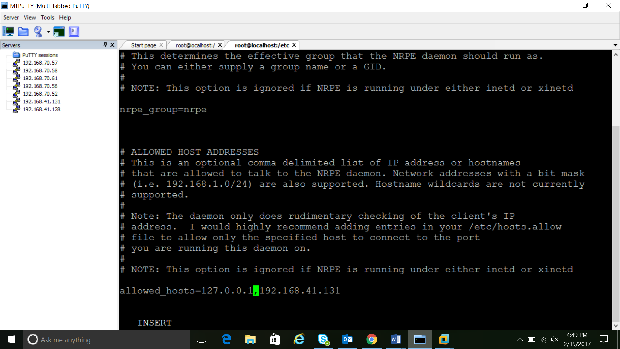

Restart NRPE to put the change into effect:

-------------------------------------------

* service nrpe start
* systemctl enable nrpe.service

Once you are done installing and configuring NRPE on the hosts that you want to monitor, you will have to add these hosts to your Nagios server configuration before it will start monitoring them.

IN NAGIOS SERVER

===================

Add Host to Nagios Configuration

=================================

On your Nagios server, create a new configuration file for each of the remote hosts that you want to monitor in /usr/local/nagios/etc/servers/

* vim /usr/local/nagios/etc/servers/nagios.cfg

Add the following to the file

define host {

use linux-server

host_name localhost.localdomain

alias clientcent

address 16.184.40.5

max_check_attempts 5

check_period 24x7

notification_interval 30

notification_period 24x7

}

With the configuration file above, Nagios will only monitor if the host is up or down.

Add the following service which need to be monitored ,

define service {

use generic-service

host_name mca4.psdgc.cloud

service_description PING

check_command check_ping!100.0,20%!500.0,60%

}

define service {

use generic-service

host_name mca4.psdgc.cloud

service_description SSH

check_command check_ssh

notifications_enabled 0

}

Please find a screen shot below for better understanding . . . .



Now save and quit

Check whether the configuration file is OK or not using the command

/usr/local/nagios/bin/nagios -v /usr/local/nagios/etc/nagios.cfg

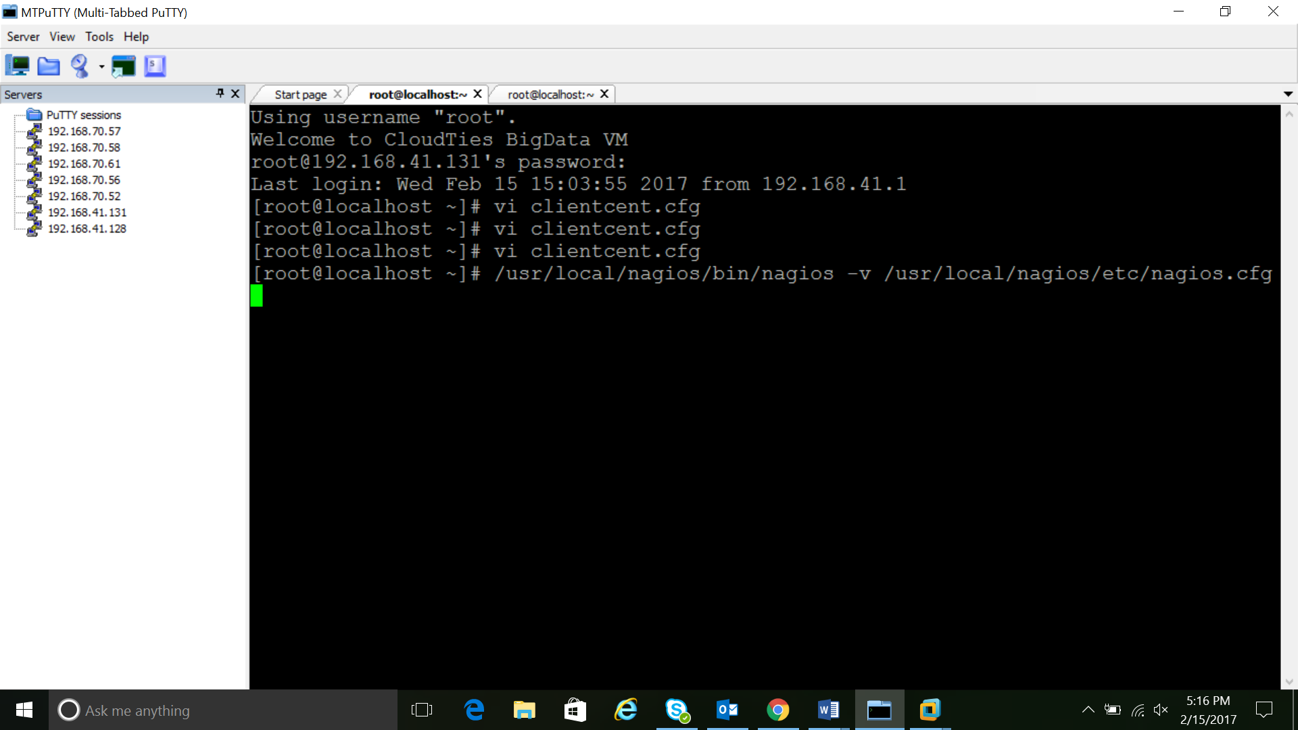

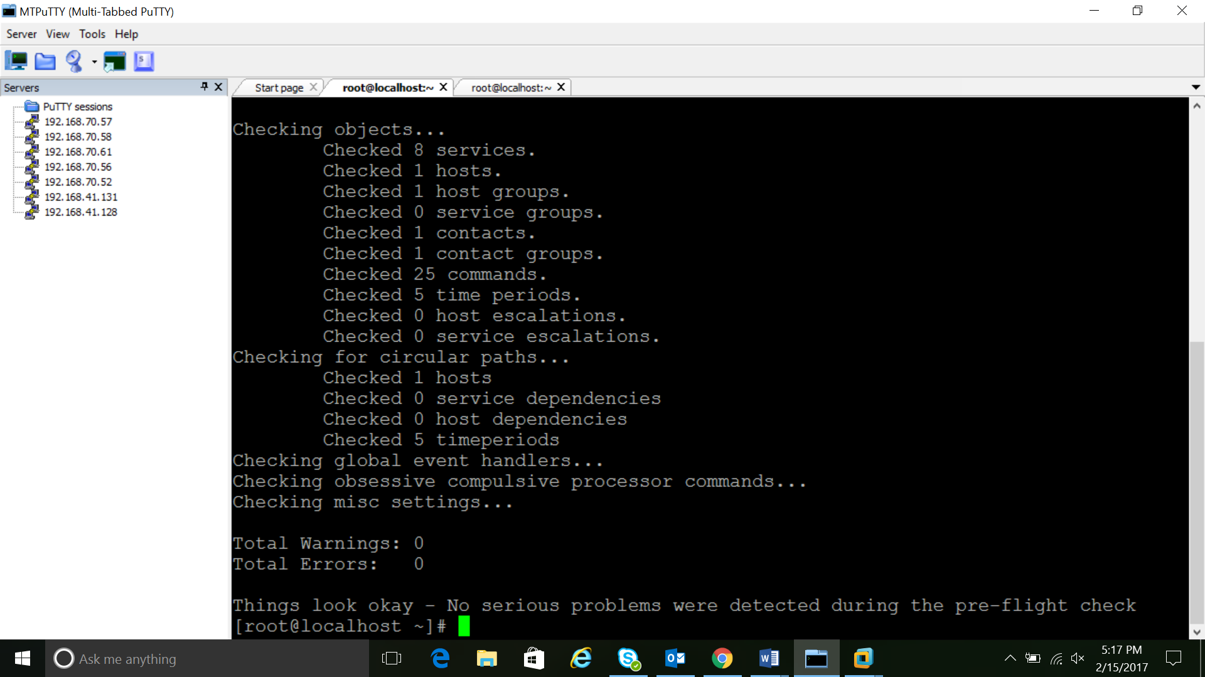

Once you are done configuring Nagios to monitor all of your remote hosts, you should be set. Be sure to access your Nagios web interface, and check out the Services page to see all of your monitored hosts and services:

NOTE:

======

Default samples of services will in /usr/local/nagios/etc/objects/localhost.cfg

**Some sample scripts**

**Below are some of the sample scripts that can be used for reference for writing the Nagios scripts.**

**For checking Nagios master:**

#!/bin/bash

if service nagios status | grep inactive

then

echo "nagios is not running"

exit 2

else

echo "nagios is running"

exit 0

fi

**Script to check space used:**

used_space=`df -h / | grep -v Filesystem | awk '{print $5}' | sed 's/%//g'`

if [ $used_space -lt 75 ]

then

echo "OK - $used_space% of disk space used"

exit 0

elif [ $used_space -gt 75 ] && [ $used_space -lt 85 ]

then

echo "WARNING - $used_space% of disk space used."

exit 1

else

echo "CRITICAL - $used_space% of disk space used."

exit 2

fi

**Script for checking xinetd:**

#/bin/bash

if service xinetd status | grep inactive

then

echo "xinetd is down | restart required"

exit 2

else

echo " xinetd is running"

exit 0

fi

**Script to check jfrog status:**

#!/bin/bash

if service artifactory check | grep pid= >> /dev/null

then

echo "jfrog artifactory is running"

exit 0

else

echo " jfrog artifactory is not running"

exit 2

fi

**Script to check total processes**

#!/bin/bash

a=$(ps aux | wc -l)

echo $a

if [ $a -lt 500 ]

then

echo "Ok"

exit 0

elif [ $a -gt 500 ] && [ $a -lt 600 ]

then

echo "WARNING"

exit 1

else

echo "CRITICAL"

exit 2

fi

**Script for Jenkins status:**

#!/bin/bash

if service jenkins status | grep inactive

then

echo "jenkins is not running"

exit 2

else

echo "jenkins is running"

exit 0

fi